INTRODUCTION
Project: Smart Library Request Workflow in Service Now
The Smart Library Request Workflow in ServiceNow is an automated solution designed to simplify and streamline the process of managing library services. It enables students, employees, or library members to request books, renew borrowed books, return library resources, and track the status of their requests through the ServiceNow Service Portal. Instead of relying on manual paperwork and traditional library management methods, the workflow automates every stage of the request process, including request submission, book availability verification, approval (if required), book issuance, notifications, and request closure. The system automatically sends email notifications to keep users informed about the status of their requests, due dates, and return reminders, ensuring better communication between users and library staff. It also maintains accurate records of issued and returned books, reducing errors and improving accountability. By integrating forms, workflows, approvals, notifications, and database updates into a single platform, Service Now helps libraries improve operational efficiency, reduce processing time, enhance user satisfaction, and ensure effective management of library resources. This smart workflow provides a modern, transparent, and reliable approach to library management, making it easier for both users and administrators to access and manage library services efficiently.

IDEATION PHASE
Problem Statement
•In many academic institutions, managing a library system manually creates challenges such as lack of real-time updates on book availability, inefficient approval processes, and limited visibility into harrowing patterns. Students often face issues knowing which books are available, while librarians struggle with tracking requests, approving or rejecting them, and maintaining accurate records of issued or returned books.
•To address these challenges, a role-based Library Management System needs to be implemented on the Service Now platform. This system should allow students to request books, while librarians manage the book inventory and approve borrow requests. Automated workflows, role-based access controls, and reports will ensure a streamlined process for both parties.
What are challenges faced without Smart Library Request Workflow in ServiceNow :
- Manual book request processing
- Time Consuming Approval Process
- No automated emails or SMS notifications
- Poor communication between users and librarians
- Duplicate or missing request records.
Objective
The objective of this project is to implement a role-based Library Management System in Service Now that simplifies the process of borrowing and managing books. The system allows students to submit borrow requests and track their status, while librarians manage the book catalog and approve or reject requests. Through automated workflows, book availability is updated in real time, role-based access ensures proper security, and reporting features like “Most Borrowed Books” provide insights for better resource management.

REQUIREMENT ANALYSIS
SOLUTION REQUIREMENT:
TEAM ID | SWTID-2026-3009
PROJECT NAME | Smart Library Request Work flow in ServiceNow.

Functional Requirements
Following are the functional requirements:
FR.No | Functional requirements | Sub requirements
FR-1 | Roles | Create roles Student and Librarian – to control system access
FR-2 | Tables | Create tables (Book, Borrow Request), create fields in the table (Book: Title, Author, Category, Status; Borrow Request: Student,  Book, Issue Date, Return Date,status.
FR-3 | Reference Qualifier | Configure reference qualifier on Borrow Request to prevent requesting books that are already issued.
FR-4 | Flow Designer | Create a flow to automate the borrow request process trigger on submission, route request to librarian for approval, update Book status to Issued and Borrow Request status on approval, and notify the student.
FR-5 | UI Policy | Create Ul Policy to make the Return “ate field mandatory once a book status Is set to  Issued, and lock fields after approval.
FR-6 | Access Control (ACL) | Configure Access Control Rules for Book and Borrow Request tables – Students can view Book records and create Borrow Requests; Librarians have full create, read, update, and delete access.
FR-7 | Report | Create a report named ‘Most Borrowed Books’ (pie chart) to give librarians insights on Borrowing trends.
FR-8 | Testing | Test the Flow, UI Policy, Reference Qualifier.

Non-functional requirements:
Following are the non-functional requirements:
FR No. | Non-functional requirements | Description
NFR-1 | Usability | The Smart Library Request Workflow provides a simple, role-based interface so students can request books and librarians can manage catalog and approvals with minimal training.
NFR-2 | Security | The Smart Library Request Workflow enforces role-based security using Access Control Rules (ACLs) so students and librarians only access data and actions permitted for their role.
NFR-3 | Reliability | The Smart Library Request Workflow consistently automates approvals and status updates through Flow Designer, ensuring accurate book tracking without failure.
NFR-4 | Performance | The Smart Library Request Workflow delivers fast response times for book requests, approvals, and report generation, performance
NFR-5 | Availability | The Smart Library Request Workflow is accessible at all times so students and librarians can request, track, and manage books without downtime.
NFR-6 | Scalability | The Smart Library Request Workflow can efficiently handle a growing number of students, books, and borrow requests as the library expands.

Data flow diagram
The Data Flow Diagram (DFD) for the Smart Library Request Workflow in Service Now illustrates how information moves through the system. A user submits a library request through the Service Now portal, where the workflow validates and processes the request. The request is then sent to the librarian for approval. After approval, the system updates the library database, sends notifications to the user, and provides access to the requested library service. This automated workflow improves efficiency, reduces manual effort, and ensures secure request processing.
Users
- Users log in to the Service Now portal.
- Users submit a library request.
- Users track the request status.
- Users receive notifications about approval or rejection.

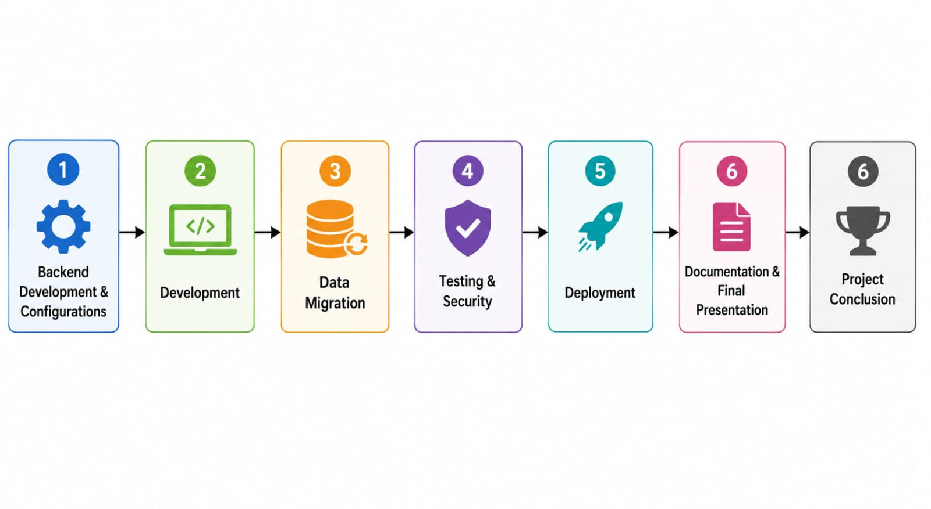
Architecture of Service Now
  - User logs in to the Service Now portal.
  - User submits a library request.
  - Request is stored in the Service Now database.
  - Flow Designer routes the request for approval.
  - Librarian reviews and approves/rejects the request
  - Notifications are sent to the user.
  - Request status and records are maintained securely..

Project Design:
Proposed solution: Smart Library Request workflow in ServiceNow
S.no | Parameter | Description
1. | Problem Statement (problem to be solved) | Educational institutions and organizations often struggle to manage library operations efficiently. Book requests, issuing, renewals, and returns are still handled manually or through disconnected legacy systems, leading to delayed approvals, misplaced records, lack of real-time visibility into book availability, and difficulty tracking overdue items. This results in poor user experience for students and staff, and increased administrative burden for library staff.
2. | Idea/Solution Description | The proposed solution is a Smart Library Request Workflow built on the ServiceNow platform-a centralized, automated system that digitizes the entire library request lifecycle. Users can raise book requests through a self-service portal or Virtual Agent chat, requests are automatically routed for approval using Flow Designer, and the system tracks issuing, due dates, renewals, and returns in real time, with dashboards giving library staff complete operational visibility
3. | Novelty/Uniqueness | Unlike traditional library management tools, this solution combines conversational Al (Virtual Agent) for hands-free requests, no-code automated approval workflows via Flow Designer, proactive notification alerts for due dates and overdue books, and live analytics dashboards – delivering an intelligent, self-service experience that eliminates manual registers and reduces staff intervention.
4. | Social Impact/Customer Satisfaction | By automating requests and approvals, the workflow significantly reduces waiting time for students and staff, increases transparency around book availability, minimizes the risk of lost or misplaced records, and encourages accountability through timely reminders -fostering a more responsible and efficient library  Culture across the institution.
5. | Business Model (Revenue Model) | The solution follows a Software-as-a-Service (SaaS) subscription model, licensed to educational institutions, universities, and corporate libraries on a per-user or per-institution basis. Tiered pricing plans  Can be offered a Basic tier covering core request and tracking features, and a Premium tier adding advanced analytics, custom reporting, and integration support.
6. | Scalability of the Solution | Built on Service Now’s enterprise-grade cloud platform, the solution is inherently scalable – capable of growing from a single library branch to a multi-campus or multi-organization deployment. It can seamlessly handle increasing numbers of users, expanding book catalog, and higher request volumes while maintaining consistent performance and reliability.

Phase-1 : Requirement Analysis &Planning
The system requires two roles: student and librarian. Students can request and track books, while librarians manage the catalog and approve requests. Two tables are needed: Book (details, status) and Borrow Request (transactions). Workflows will automate approvals and status updates, ACLs will control access, and reports like "Most Borrowed Books" will give insights. Planning covers defining tables, roles, workflows, and test cases to ensure smooth implementation.
Business Objective
The main business objective of this project is to create a digital library system in Service Now that reduces manual effort, improves accuracy in book tracking, and enhances user experience for both students and librarians. By automating borrow requests, approvals, and book status updates, the system ensures efficient operations, transparency, and faster access to resources. Additionally, role-based controls and reporting features support better decision-making and effective management of library resources.
Functional Scope
The Library Management System on Service Now will provide the following key functions:
- Book Management – Librarians can add, update, and maintain book details with status tracking (Available, Issued, Lost, Returned).
- Borrow Requests – Students can create and track requests; librarians can approve, reject, or close them.
- Workflow Automation – Approval of requests will automatically update the book status.
- Role-Based Access – Students have limited access to requests, while librarians manage the entire system.
- Reporting – Generate insights such as “Most Borrowed Books” for library usage analysis.
Stakeholder Mapping
- Students – Request and track books; expect easy access and quick approvals.
- Librarians – Manage catalog, approve/reject requests, generate reports; need efficiency and accuracy.
- System Administrators – Configure tables, workflows, and roles; ensure secure and stable systems.
- Management/Faculty – Use reports for planning and resource allocation.
- IT Support Team – Provide technical support, upgrades, and system reliability.
Execution Roadmap
1.Role Setup – Create student and librarian roles.
2.Table Design – Build Book and Borrow Request tables with required fields.
3.Form Configuration – Add fields, set default values, and establish related lists.
4.Workflow Automation – Configure Flow Designer for approval and book status updates.
5.Access Control – Define ACLs for role-based permissions.
6.UI Enhancements – Apply UI Policies for form restrictions and usability.
7.Reporting – Create dashboards/reports like Most Borrowed Books.
8.Testing & Validation – Use sample data, impersonation, and debug tools to verify end-to-end flow
Milestone-1: Create Roles
Define roles: student and librarian.
Ensure role separation for access control (students = request, librarians = manage).
Milestone-2: Create Tables Create a Book table (u_book).
Create a Book table (u_book).
Create a Borrow Request table (u_borrow_request).
Link Borrow Request → Book.
Milestone-3: Add Fields to Book
Add fields: Title, Author, ISBN, Status.
Configure Status choices: Available (default), Issued, Lost.
Milestone-4: Add Fields to Borrow Request
Add fields: Requested By, Book (Reference), Request Date, Status.
Configure Status choices: Requested (default), Approved, Rejected, Returned.
Milestone-5: Show Borrow Requests on Book (Related List)
Add Borrow Request related list on Book form.
Verify relationship: Book → Borrow Request.
Milestone-6: Prevent Requesting Already-Issued Books (Reference Qualifier)
Configure Reference Qualifier on Borrow Request → Book field.
Condition: Show only books where Status = Available.
Milestone-7: Flow Designer – Approve → Issue Book
Create Flow: Trigger when Borrow Request → Status changes to Approved.
Action: Update Book → Status = Issued.
Optional: Send email notification to requester.
Milestone-8: UI Policy
Apply UI Policy: When Borrow Request Status = Approved → lock fields (Book, Requested By, etc.).
Improves form usability and prevents accidental edits.
Milestone-9: Access Control (ACLs)
Define ACLs for Book table:
Librarians = Create/Write/Delete.
Students & Librarians = Read.
Define ACLs for Borrow Request table:
Students = Create/Read (own records).
Librarians = Approve/Write/Delete.
Milestone-10: Report – “Most Borrowed Books”
Build Report from Borrow Request table.
Group by Book, Count requests.
Display the top 5 most borrowed books as a chart or list.
Phase:2-Backend Development & Configurations
Creation of roles
Description
1.Open Service Now
2.Click on All → search for Roles.
3.Select User Administration → Roles.
4.Click on New.
5.Enter Role Name as librarian → click Submit.
6.Again, click on New.
7.Enter Role Name as student → click Submit.
8.Verify that both roles (librarian and student) are listed in the Roles module
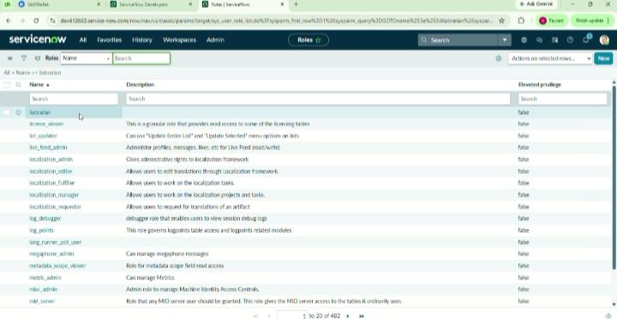
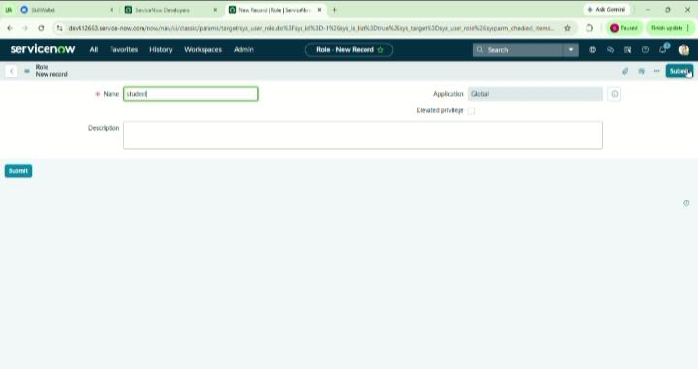
Create tables
1.Open Service Now.
2.Click on All → search for Tables.
3.Select System Definition → Tables.
4.Click on New.
5.Enter Label as Book → click Submit (this creates the table u_book).
6.Again, click on New.
7.Enter Label as Borrow Request → click Submit (this creates the table u_borrow_request).
8.Verify that both tables (Book and Borrow Request) are listed under the Tables module.
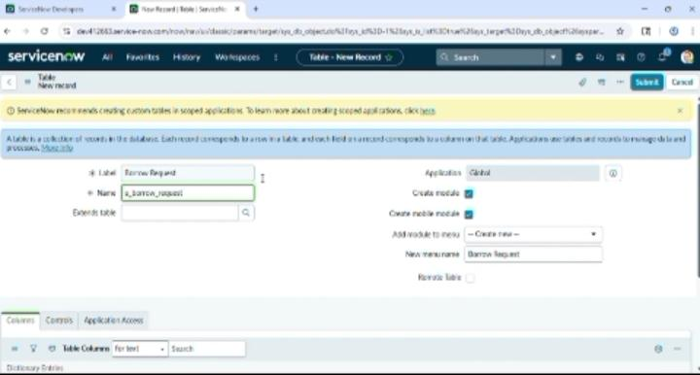
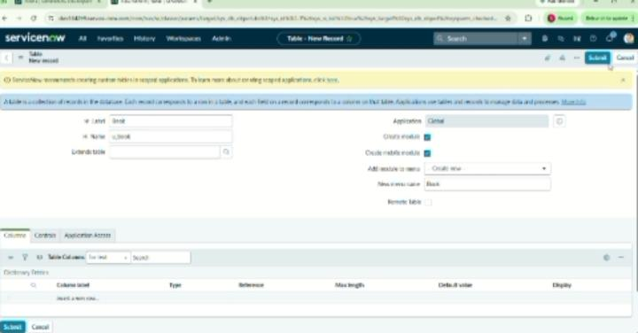
Add fields to book table
1.Open Service Now.
2.Click on All → search for Tables.
3.Select System Definition → Tables.
4.From the list, open the table Book (u_book).
5.Scroll down to the Columns (Dictionary) related list.
6.Click on New to add a new field.
7.Enter Column Label as Title, select *Type = String → click Submit.
8.Again, click on New. Enter Column Label as Author, select *Type = String → click Submit.
9.Again, click on New. Enter Column Label as ISBN, select *Type = String → click Submit.
10.Again, click on New. Enter Column Label as Status, select *Type = Choice → click Submit.
11.Open the Status field you just created.
12.In the Choices related list, click New and add values: Available, Issued, Lost.
13.Set the Default Value of Status = Available.
14.Click Update to save.
15.Verify that the Book form now has fields: Title, Author, ISBN, Status.

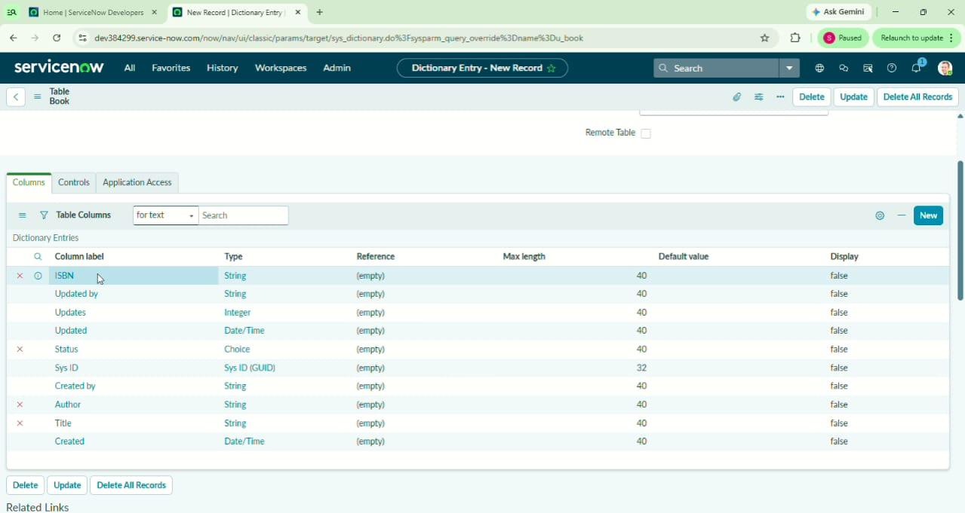
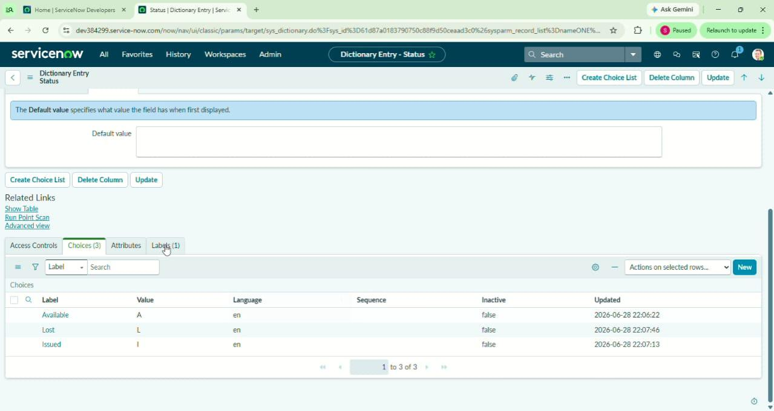

Add fields to borrow request
1.Open Service Now.
2.Click on All → search for Tables.
3.Select System Definition → Tables.
4.From the list, open the table Borrow Request (u_borrow_request).
5.Scroll down to the Columns (Dictionary) related list.
6.Click on New to add a new field.
7.Enter Column Label as Requested By, select Type = Reference, set Reference = User [sys_user] → click Submit.
8.Again, click on New. Enter Column Label as Book, select Type = Reference, set Reference = Book [u_book] → click Submit.
9.Again, click on New. Enter Column Label as Request Date, select Type = Date/Time → click Submit.
10.Again, click on New. Enter Column Label as Status, select Type = Choice → click Submit.
Open the Status field you just created.
In the Choices related list, click New and add values: Requested, Approved, Rejected, Returned.
Set the Default Value of Status = Requested.
Click Update to save.
Verify that the Borrow Request form now has fields: Requested By, Book, Request Date, Status.

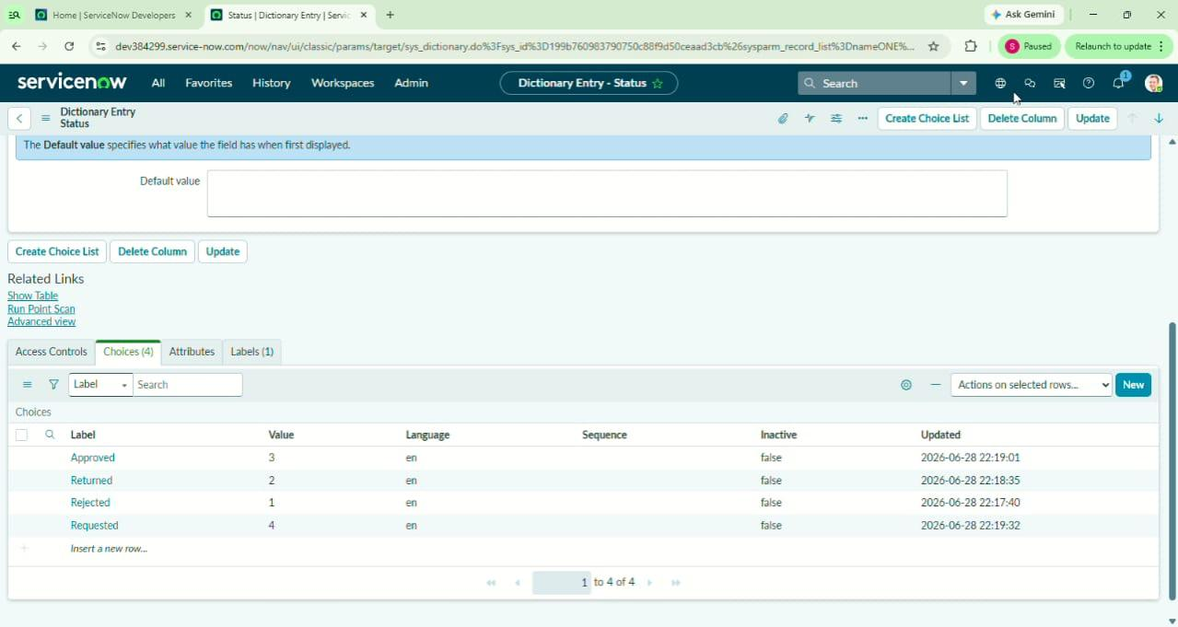
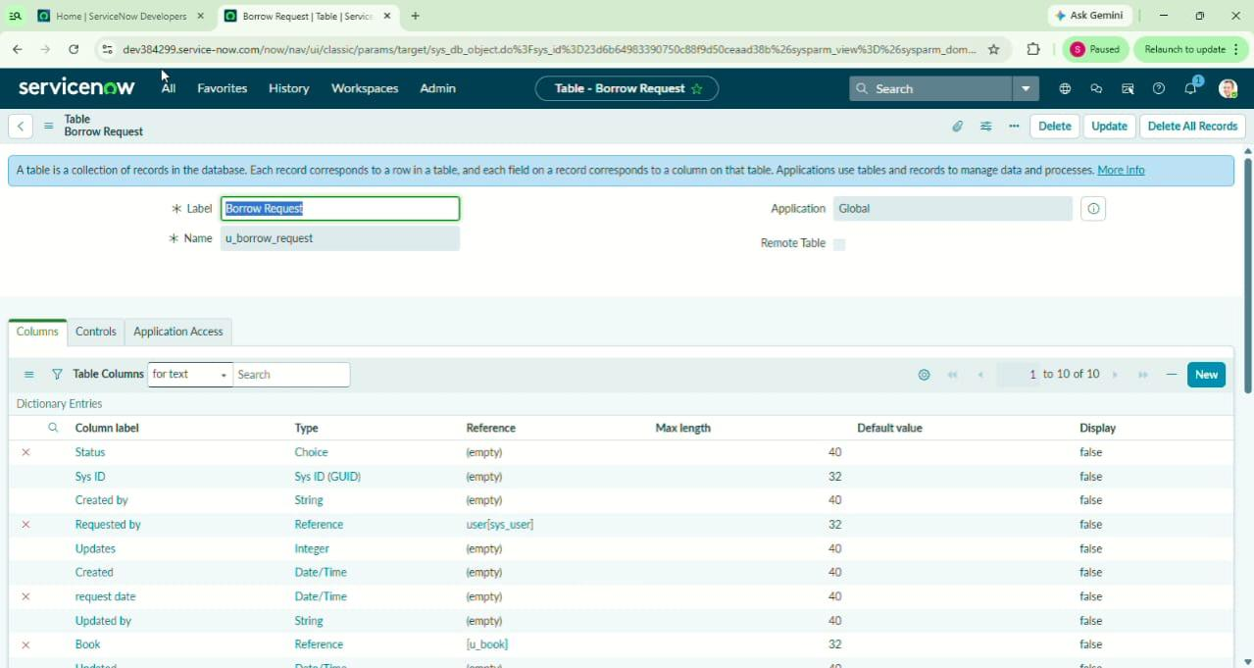

Configure Reference Qualifier (Prevent Requesting Already-Issued Books)
1.Open Service Now.
2.Click on All → search for Tables.
3.Select System Definition → Tables.
4.From the list, open the table Borrow Request (u_borrow_request).
5.Scroll down to the Columns (Dictionary) related list.
6.Open the field Book (Reference field to Book [u_book]).
7.In the field form, scroll to the Advanced View (click the gear ️ if needed).
8.Locate the Reference Qualifier section.
9.Select Simple type.
10.In the Reference Qualifier Condition, set: Status is Available
11.Click Update to save the field.
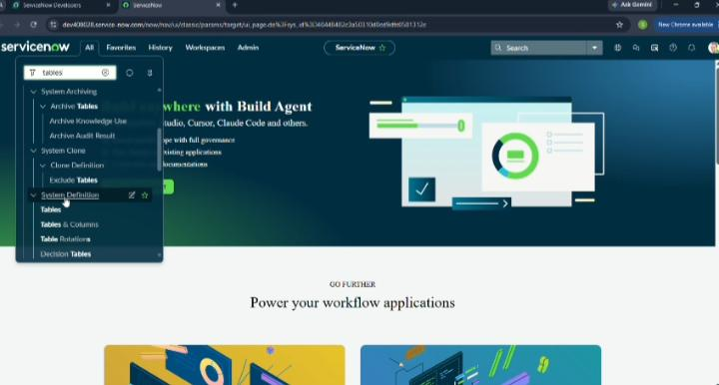

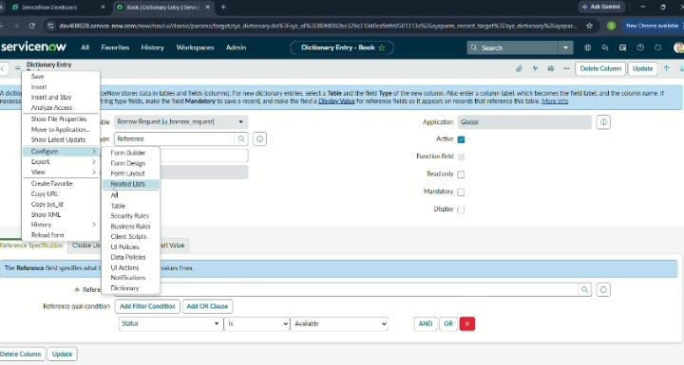
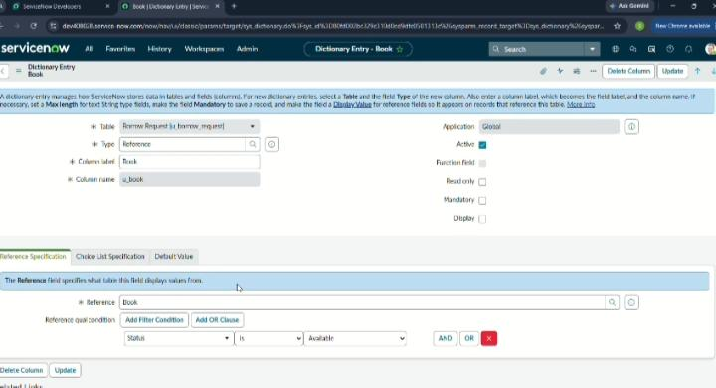

Phase-3: Development
Create Flow in Flow Designer
1.Open Flow Designer
1.Open Service Now.
2.Click on All → search for Flow Designer.
3.Select Flow Designer and click New → Flow.
4.Enter Name as Borrow Request Approval Flow → click Submit.
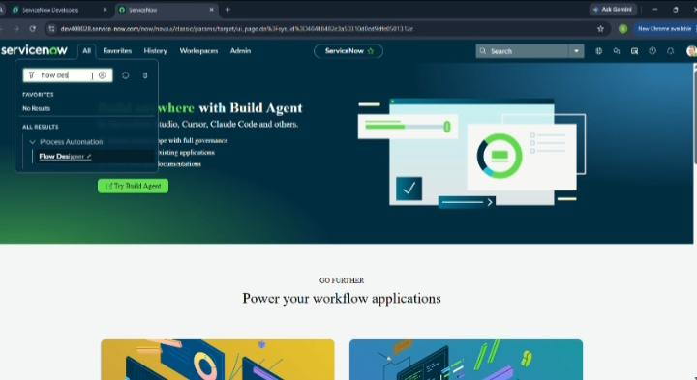

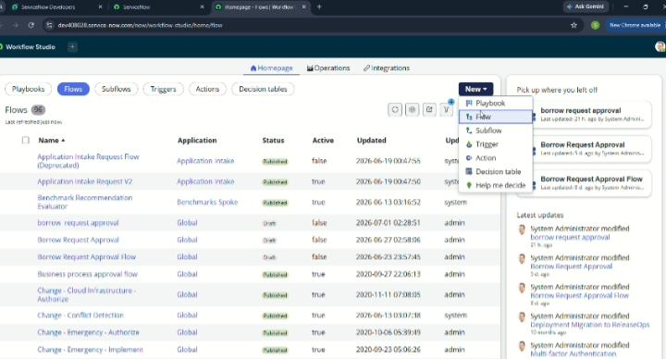
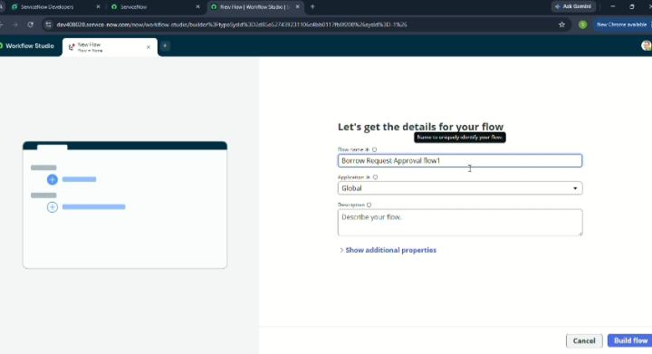
1.Add Trigger (When to Run the Flow)
1.In the Flow Designer canvas, click + Add Trigger.
2.Select Created or Updated.
3.Choose Table = Borrow Request [u_borrow_request].
4.Add condition: Status = Requested.
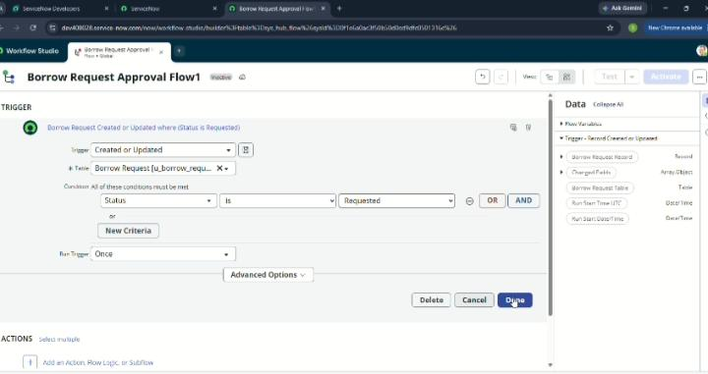
5.Click Done.
3.Add Action – Approval
1.Click on + Add Action.
2.Search for Ask for Approval.
3.Set Approvers = Role: librarian.
4.Approval conditions:
5.On Approve → continue flow.
6.On Reject → set Status = Rejected.
7.Click Done.
4. Add Action – Update Record (Issue Book)
1.Click on + Add Action.
2.Search for an Update Record.
3.Choose Table = Book [u_book].
4.Condition: Sys ID = Current.Book (the one from Borrow Request).
5.Set Status = Issued.
6.Click Done.

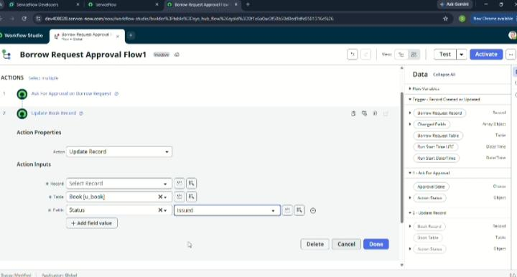

5.Add Action – Update Borrow Request Record
1.Click on + Add Action.
2.Search for an Update Record.
3.Choose Table = Borrow Request [u_borrow_request].
4.Condition: Sys ID = Current.
5.Set Status = Approved.
6.Click Done.

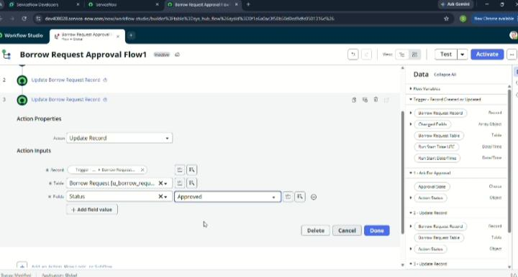
6.Add Action – Send Email (Notification)
1.Click on + Add Action.
2.Search for Send Email.
3.Set To = Requested By (Borrow Request → Requested By field).
4.Subject: Your Borrow Request has been Approved.
5.Body: The book [Book.Title] has been issued to you. Please collect it from the library.
6.Click Done

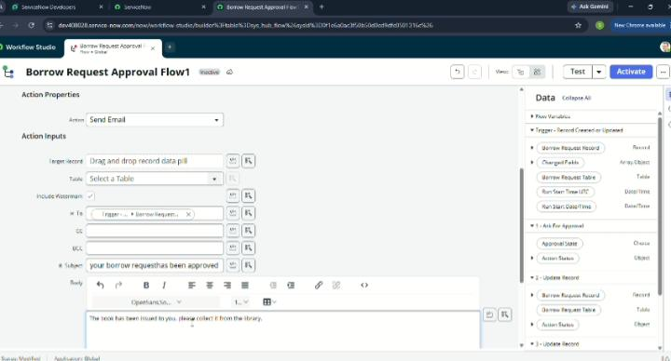
7.Save and Test Flow
1.Click Save → Activate.
2.Create a test Borrow Request with Status = Requested.
3.Verify: Librarian gets approval → On approve, Book. Status = Issued, Borrow Request. Status = Approved, and student receives an email.
Create UI Policy
1.Open Service Now.
2.Click on All → search for UI Policies.
3.Select System UI → UI Policies.

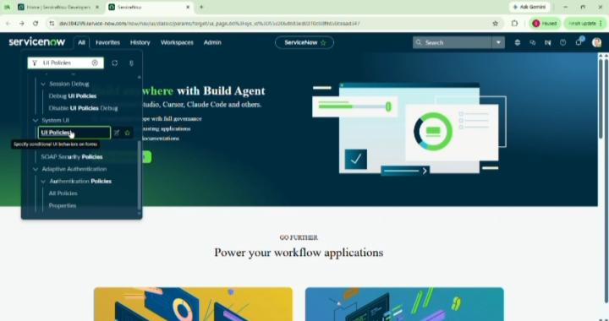
4.Click on New.
5.Enter Table = Borrow Request [u_borrow_request].
6.Enter Short Description = Make Return Date mandatory when Issued.
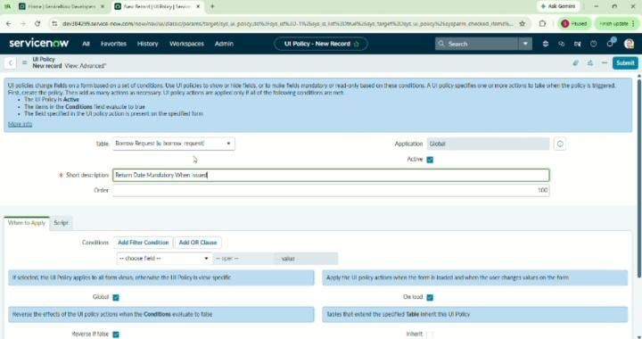
7.Submit the record.
8.Reopen the created UI Policy record.
9.In the Conditions section, set: Status = Issued.
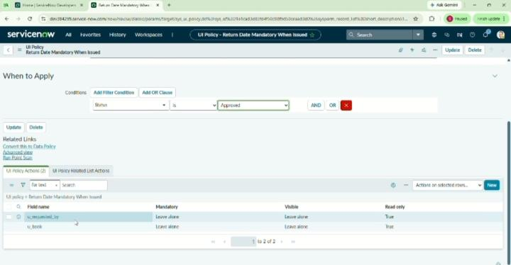
10.In the UI Policy Actions related list, click New

11.Select Field = Return Date.
12.Set Mandatory = True.
13.Set Visible = True.
14.Submit the UI Policy Action.
Phase-4: Data Migration,Testing & Security
Access Control for Book Table
1.Open Service Now.
2.Click on All → search for Access Control.
3.Select System Security → Access Control (ACL).
4.Click New.

5.Select Table = Book [u_book].
6.Choose Operation = read.
7.Set Requires role = student, librarian.
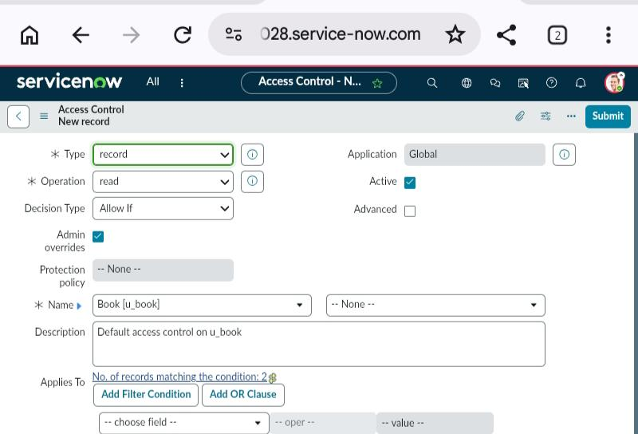

8.Submit.
9.Again, click New.
10.Select Table = Book [u_book].
11.Choose Operation = write.
12.Set Requires role = librarian
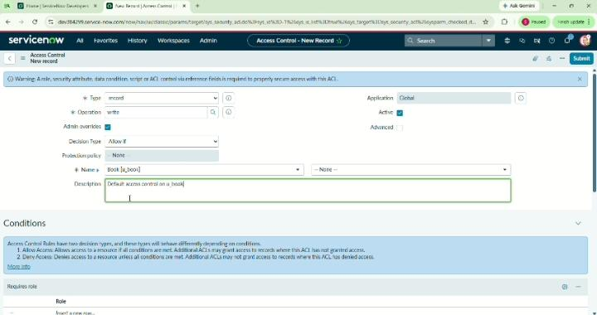
13.Submit.
14.Again, click New.
15.Select Table = Book [u_book].
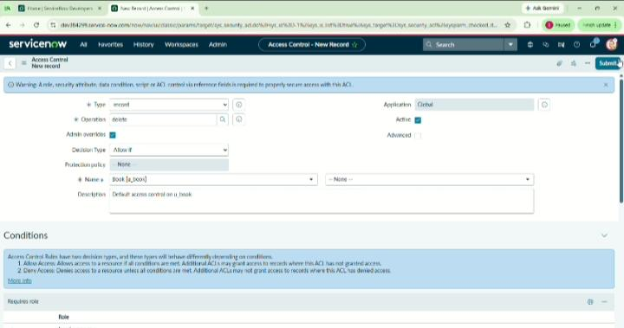
16.Choose Operation = delete

17.Set Requires role = librarian.
18.Submit.
Result: Students can only read books, librarians can read, write, and delete.
Access Control for Borrow Request Table
1.Open ServiceNow.
2.Click on All → search for Access Control.
3.Select System Security → Access Control (ACL).
4.Click New.
5.Select Table = Borrow Request [u_borrow_request].
6.Choose Operation = create.
7.Set Requires role = student.
8.Submit.
9.Again, click New.
10.Select Table = Borrow Request [u_borrow_request].
11.Choose Operation = read.
12.Set Requires role = student, librarian.

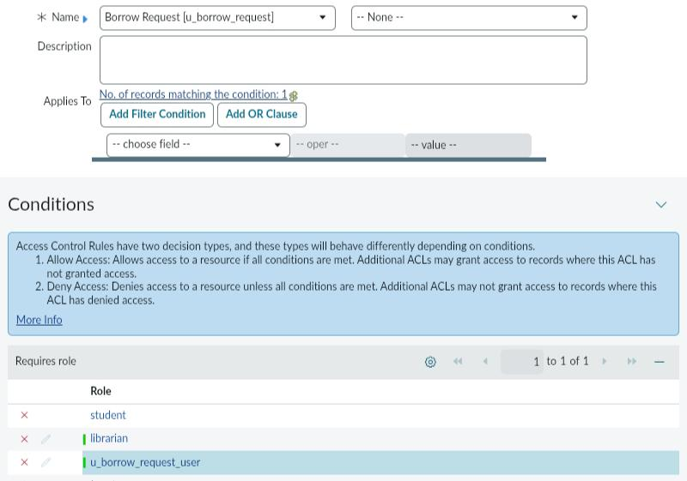
13.Submit.
14.Again, click New.
15.Select Table = Borrow Request [u_borrow_request].
16.Choose Operation = write.
17.Set Requires role = librarian.
18.Submit.
19.Again, click New.
20.Select Table = Borrow Request [u_borrow_request].
21.Choose Operation = delete.
22.Set Requires role = librarian.
23.Submit
Result: Students can create and read their borrow requests, librarians can read, update, and delete requests.
Create report
1.Open Service Now.
2.Click on All → search for Reports.
3.Select Reports → View / Run.
4.Click on New.
5.Enter Name = Most Borrowed Books.
6.Select Source Type = Table.
7.Select Table = Borrow Request [u_borrow_request].
8.Choose Type = Bar Chart (or Pie Chart as needed).
9.In the Group by field, select Book.
10.In the Aggregate field, select Count.
11.Add a filter: Status = Approved (to count only issued books).
12.Click Run to preview the report.
13 Adjust chart options (Title, Labels, Legend) as required.
14.Click Save.
15.To publish, click Sharing → Add roles (student, librarian).

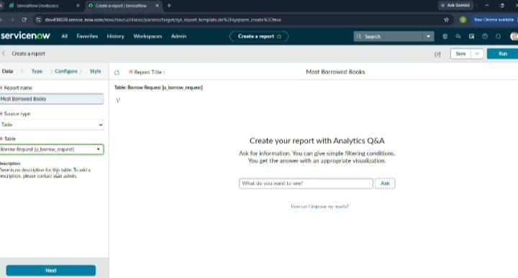
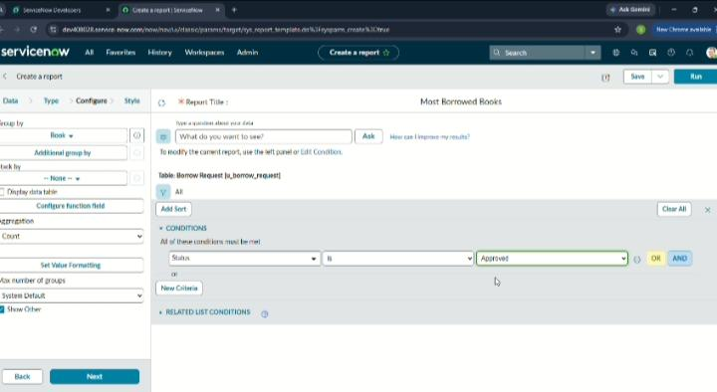

Phase-5: Deployment, Documentation & Final Presentation
Troubleshooting
Flow Execution & Logs
Verified end-to-end execution of the Borrow Request Approval Flow using Flow Designer Execution Details. Checked trigger conditions, approvals, and book issuance updates.
Reference Qualifier Issues
Debugged cases where already-issued books were still showing in the Borrow Request form. Corrected reference qualifier conditions to filter only available books.
UI Policy Behavior
Tested Borrow Request form to ensure Return Date became mandatory when Status = Issued. Verified field visibility and mandatory settings across portal and platform views.
Access Control Validation
Checked that students could only create/read their own Borrow Requests while librarians had full access. Adjusted ACL conditions to restrict unauthorized access.
Report Accuracy
Validated the “Most Borrowed Books” report to ensure only approved/issued requests were counted. Fixed grouping to display correct book titles.
Adherence to Timelines
- Executed project based on the defined milestones:
- Creation of Roles
- Creation of Tables
- Adding Fields (Book & Borrow Request)
- Reference Qualifier Implementation
- Flow Designer Setup (Approval & Issuance)
- UI Policy Configuration
- Access Control Setup
- Report Creation (“Most Borrowed Books”)
- Testing & Validation
Innovation
End-to-End Automation: Automated the book borrowing process by integrating custom tables, Flow Designer, and approvals, eliminating manual tracking of borrow requests.
Optimized Request Handling: Implemented reference qualifiers to ensure only available books can be requested, reducing errors and duplicate borrow entries.
Maintainability & Scalability: Designed the solution using out-of-the-box ServiceNow features like Flow Designer, UI Policies, and ACLs, ensuring easy maintenance and future scalability.
User Experience Enhancements: Applied UI policies to make Return Date mandatory only when a book is issued, keeping forms clean and user-friendly for both students and librarians.
Document Technical Blueprint
Variables:
- Book Title and Author
- Borrower (auto-populated with current user, editable if borrowing for others)
- Borrow Date (auto-filled with current date)
- Return Date (mandatory only when book is issued)
Approval Use Cases:
- Librarian Approval required automatically when a student raises a borrow request.
- Auto-approval for requests made by librarian role (for testing or internal usage).
Fulfillment Task Use Cases:
- Catalog tasks created for the Librarian group to issue the book.
- Automatic update of Borrow Request status to “Issued” once approved.
- Automatic updated of Borrow Request status to “Returned” when the book is marked as returned
Document Setup Manual
Provided step-by-step manual for recreating the solution in a new Personal Developer Instance (PDI):
- Role creation (Librarian, Student)
- Table creation (Book, Borrow Request)
- Field configuration for each table
- Reference qualifier setup for available books
- Flow Designer configuration (Approval → Issue → Return)
- UI Policy setup for mandatory Return Date
- Access Control rules for students and librarians
- Report creation (“Most Borrowed Books”)
- Test data submission performed to validate borrow/return flow
- Screenshots and order of operations included for clarity
Project Demo Video Planning
Demo includes:
- Portal walkthrough: Home → Library Services → Submit Borrow Request
- Live book borrow request submission by a student
- Dynamic approval flow handled by librarian
- Email notification triggers for request approval and issuance
- Request and book status tracking (Requested → Approved → Issued → Returned)
- Includes narration for each step and role-based perspectives (Student, Librarian)
Visual Demonstration
Captured:
- Form UI behaviour (e.g., Return Date becomes mandatory only when a book is issued)
- Approval records in the Borrow Request timeline (Student request → Librarian approval → Issued)
- Flow logs showing the end-to-end execution path (Request submitted → Approved → Issued → Returned)
- Annotated visuals with labels and highlights to explain each stage clearly
Explanation Clarity
Explanation Clarity
- Documentation and presentation follow logical, sequential structure:
- What → Why → How → Outcome
- Each step includes:
- Clear headings for every configuration (Roles, Tables, Flow, UI Policy, etc.)
- Labelled screenshots of Service Now setup and execution
- Explanatory notes for easy replication in a new PDI
Realism & Quality
- Workflow mimics real-world library operations, including:
- Role-based approvals (Student requests → Librarian approves)
- Data validations (book availability check, mandatory return date)
- Solution tested with realistic use cases and sample data (multiple students requesting the same book, overdue returns).
Scalability & Future Plan
- Future enhancements considered:
- Auto-notifications for overdue books and reminders via email/SMS
- Integration with external library systems or digital catalog APIs
- Enhanced reporting dashboards (borrow frequency, student activity, overdue analysis)
- Expansion to other academic services (lab equipment requests, study room booking, digital resource access)

Project Planning & Scheduling:
Assigned task to the Group members as show in below.
Functional Requirements | User Story | No.of. activity | Team Members
Requirement analysis & planning | As a  project team, I want business objectives, functional scope, stakeholder mapping & execution roadmap defined, so the project direction is clear. | 4 | V.Sirisha
Backend development & configuration | As a project team, I want business objectives, functional scope, stakeholder mapping & execution roadmap defined, so the project direction is clear. | 2  4 | V.Sirisha  P.Jeevita
Development | As a developer,  want roles created & 1 tables set up (Book & Borrow Request), 50 the backend structure is ready | 2 | P.Jeevita
Data migration, testing & security |  | 3 | V.Prasanna
Deployment, Documentation & Final Presentation |  | 3  5 | V.Prasanna  Y.Pavani
Conclusion |  | 1 | Y.Pavani

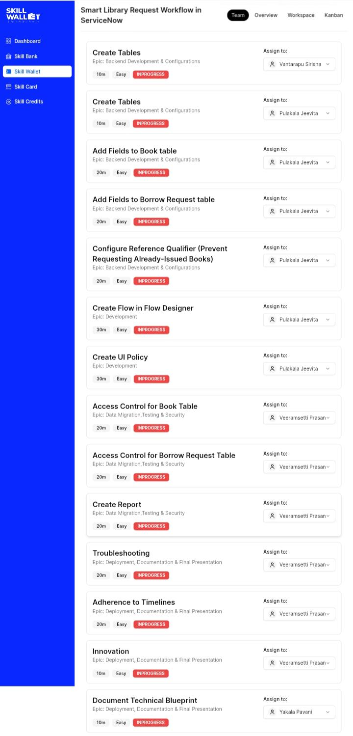

Phase-6: Project Conclusion
Conclusion
The Library Management Project successfully streamlined the process of borrowing and managing books within Service Now by integrating role-based access, automated approvals, and dynamic workflows. Students can easily submit barrow requests, while librarians efficiently review, approve, and issue books with proper validations. The solution ensures transparency through status tracking, notifications, and reporting features. By combining automation with usability, the project delivers a scalable foundation that can be extended to broader academic services in the future.

Advantages&Disadvantages
Advantages:
- Saves time by automating the library request process, reducing manual effort and speeding up request handling.
- Improves efficiency by automatically assigning requests to the appropriate approvers and completing tasks faster.
- Allows users to submit and track their requests through a self-service portal, providing a better user experience.
- Reduces human errors by eliminating manual data entry and ensuring that all requests follow the same workflow.
- Sends automatic notifications and updates to users at every stage of the request process, improving communication.
- Stores all library request records in a centralized system, making it easy to manage data, generate reports, and maintain security.

Disadvantages
- Requires a high initial investment for ServiceNow licensing, implementation, and workflow configuration.
- Needs regular maintenance and updates to keep the workflow secure, efficient, and error-free.
- Depends on a stable internet connection, making the system inaccessible during network failures.
- Advanced customization and integration with other systems require experienced ServiceNow developers.
- Users and library staff need training before they can use the system effectively.
- If the system experiences downtime or technical issues, library requests and approvals may be delayed until the service is restored.

